**VShare Securities**

**PROJECT REPORT**

***Submitted by***

**Abinaya.T (722816104003)**

**Rishwanth.S (722816104133)**

**Gowtham.N**

**(722816104052**

***in partial fulfillment for the award of the degree***

***of***

**BACHELOR OF ENGINEERING**

***in***

**COMPUTER SCIENCE AND ENGINEERING**

**SRI ESHWAR COLLEGE OF ENGINEERING**

**COIMBATORE-641 202**

**ANNA UNIVERSITY: CHENNAI 600 025**

**APRIL 2020**

**ANNA UNIVERSITY : CHENNAI 600 025**

**BONAFIDE CERTIFICATE**

**Certified that this project report “VSHARE SECURITIES ”**

**is the bonafide work of"ABINAYA.T, RISHWANTH.S, GOWTHAM.N” who carried out the project work under my supervision.**

**<<Signature of the Head of the Department>> <<Signature of the Supervisor>>**

**SIGNATURE SIGNATURE**

**<<Name>> <<Name>>**

**HEAD OF THE DEPARTMENT SUPERVISOR**

**<<Academic Designation>>**

**<<Department>> <<Department>>**

**<<Full address of the Dept & College >> <<Full address of the Dept & College >>**

**DECLARATION**

WE,

**ABINAYA.T[722816104003], RISHWANTH.S[722816104133], GOWTHAM.N[722816104052]**

Declare that the project entitled “VSHARE SECURITIES”, submitted in partial fulfillment to Anna University as the project work of Bachelor Of Engineering (Computer Science and Engineering) Degree, is a record of original work done by us under the supervision and guidance of Mr. NAVEEN DURAI, Assistant Professor, Sri Eshwar College Of Engineering, Coimbatore.

Place: Coimbatore

Date:

**[ABINAYA.T]**

**[RISHWANTH.S]**

**[GOWTHAM.N]**

Project Guided by

---------------------------------

**[Mr. NAVEENDURAI, AP/CSE]**

**ABSTRACT**

The purpose of VSHARE securities is to automate the existing system by the help of computerized equipments and full-fledged computer software, fulfilling requirements so that their valuable data/information can be stored for a longer period with easy accessing and status tracking of each stocks. The required hardware and software are easily available and easy to work with. It can assist the user to get the latest information about the stock market rather than checking other details from the news,internet etc. Basically the project describes how to manage for good performance and better service for the clients.

It may be helpful in collecting the stock information in a very short time ,the collection Will be obvious , simple and sensible. It will help the customer to know the status details of the passed year perfectly and vividly and also helps in deciding the stock in which the customer has to invest the money.

• It satisfy the user requirements

• Be easy to operate

• Have a good user interface

• Be expandable

**ACKNOWLEDGEMENT**

The success of a work depends on a team and cooperation. We take this opportunity to express our gratitude and thanks to everyone who helped me in our project. I would like to thank the management for the constant support provided by them to complete this project.

It is indeed our great honor bounded duty to thank my beloved **ChairmanMr. R. Mohanram,** for his academic interest shown towards the students. I am indebted to our Director **Mr. R. Rajaram**, for motivating and providing us with all facilities.

We wish to express our sincere regards and deep sense of gratitude to **Dr. SudhaMohanram, M.E, Ph.D.,Principal,** for the excellent facilities and encouragement provided during the course of the study and project.

At this pleasing moment of having successfully completed our project We would like to convey our thanks and gratitude to **Mr.KannanNarasimhan** and **Mr.IlangoMurugesan,** IT-Directorsof Excellence, for their constant encouragement for completing this project successfully.

We are indebted to **Dr. Subha R, M.E., Ph.D.,HOD**, Department of Computer Science and Engineering for having permitted me to carry out this project and giving the complete freedom to utilize the resources of the department.

We express our sincere thanks to our project Co-coordinators **Mr.Sivakumar** and **Mr. Karthikeyan N** Assistant Professors of Computer Science and Engineering Department for their valuable guidance and encouragement given to us for this project.

We also extend my heartfelt thanks to my internal project Guide **Mr. NAVEENDURAI** ,Assistant Professor of Computer Science and Engineering Department for providing me their support and guidance which really helped us.

We solemnly express our thanks to all the teaching and non-teaching staff of the Computer Science and Engineering Department, family and friends for their valuable support which inspired me to work on this project.

**TABLE OF CONTENTS**

1 INTRODUCTION

1.1 PURPOSE

1.2 SCOPE

1.3 DEFINITIONS, ACRONYMS AND ABBREVIATIONS

1.4 REFERENCES

2 ASSUMPTIONS

3 PROJECT OVERVIEW AND USECASE DIAGRAMS

4 DETAILED DESIGN FOR MODULE

4.1 DETAILED DESIGN FOR FEATURE

4.1.1 User Profile

4.1.2 Navigation Map

4.1.3 UI Screen Design

4.1.3.1 Screen Layout

4.1.3.2 Validations

4.1.4 Object Model/Data Flow Design

4.1.4.1 Interface Description

4.1.4.2 Class Design

4.1.4.2.1 Algorithmic/Business Logic Description (Optional)

4.1.4.2.2 Local Data Structure (Optional)

4.1.4.3 Data Transfer/Value objects

4.1.4.4 Related Database Tables

4.1.4.5 Dependencies with Other Sub-systems/Components

4.2 DETAILED DESIGN FOR FEATURE

5 DETAILED DESIGN FOR MODULE

6 DATABASE DESIGN

6.1 ENTITY RELATIONSHIP DIAGRAMS

7 Non Functional Requirements

7.1 SNAPSHOTS:

7.1.1 MAIN PAGE

7.1.2 SIGN IN PAGE

7.1.3 SIGN UP PAGE

7.1.4 STOCK PAGE

**2 Introduction**

**2.1 Purpose**

The purpose of VSHARE securities is to automate the existing system by the

help of computerized equipments and full-fledged computer software, fulfilling

requirements so that their valuable data/information can be stored for a longer

period with easy accessing and status tracking of the stocks. The required

hardware and software are easily available and easy to work with. It can assist

the user to get the latest information about the news rather than browsing the internet . Basically the project describes how to manage for good performance

and better service for the clients.

**2.2 Scope**

It may be helpful in collecting the stock information in a very short time ,the collection

Will be obvious , simple and sensible. It will help the customer to know the

stock market details of the passed year perfectly and vividly and also helps in deciding the stock in which the customer has to invest the money to get profited..

• It satisfy the user requirements

• Be easy to operate

• Have a good user interface

• Be expandable

**2.3 Definitions, Acronyms and Abbreviations**

• Client: A business entity using the services offered by the

VSS and accepting some sort of service level agreement.

• Service: A means of giving the information of the stock market and the graph of the rise of stock and the interface to communicate with the broker.

**2.4 References**

[This sub-section must provide a complete list of all references. Identify each

document by title, document number and the version. Specify the sources from

which the references can be obtained.

**3 Assumptions**

To be helpful for the client in tracking the stocks and gives the latest information about the stock market with a graph.

**4 PROJECT OVERVIEW AND USECASE DIAGRAMS**

Project Overview:

**USE CASE DIAGRAM**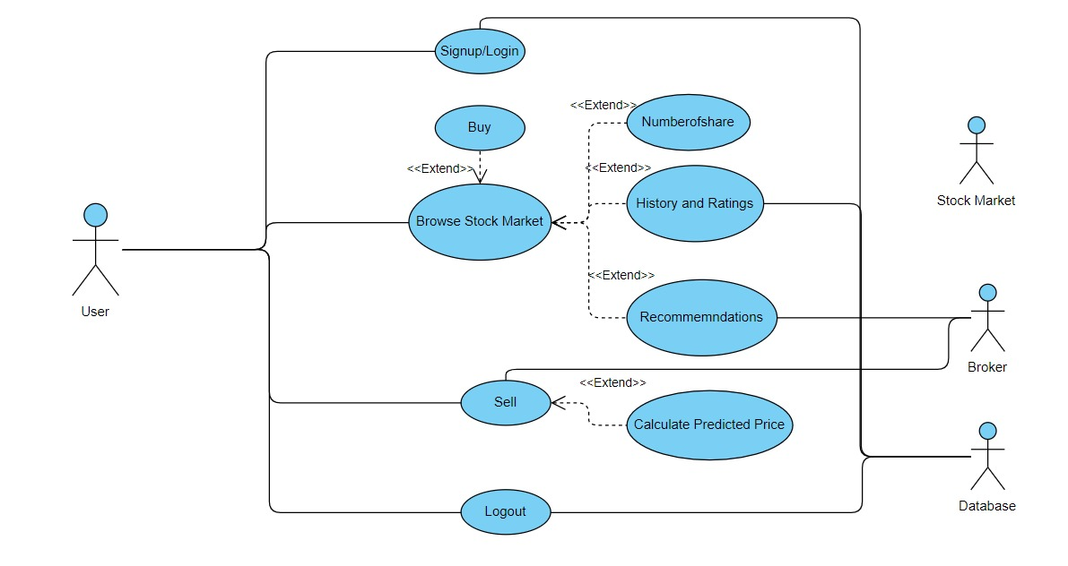

**Detailed Design for Module: <<Module Name>>**

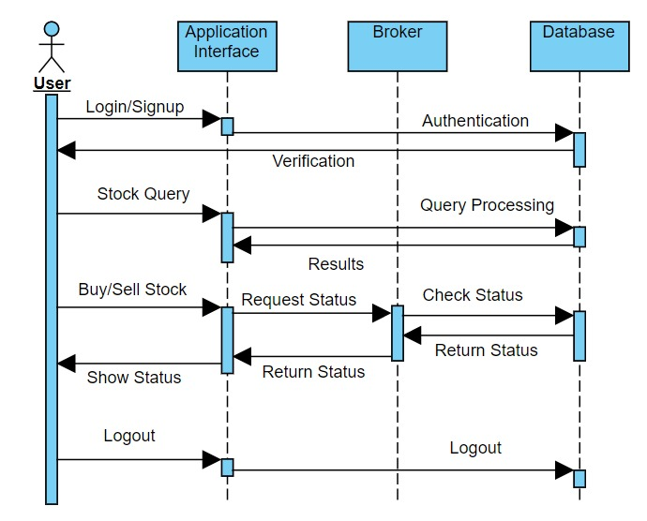

**3.1 Detailed Design for Feature:**

**3.1.1 User Profile**

[Describe the different user types with the security profiles and specify the roles that can access these screens.]

**3.1.2 Navigation Map**

[Describe the navigation map along with use case traceability of all screens for this feature.]

**3.1.3 UI Screen Design**

Page Summary

Name Search for stocks

Description The client can keep the status of the stocks and gets the latest information about the stock market and the stock which we invested. This page also tells us about the profit and lost occurred in the stock.

**3.1.3.1 Screen Layout**

[Include a screen shot and describe each element/button in the following table.

**3.1.3.2 Validations**

Error Trigger Action Description

If the user displays the wrong information. Displays the message “Please select information error”. Prompts the user to give the correct information about the column.

**3.1.4 Object Model/Data Flow Design**

[This sub-section describes the detailed design for the system pertaining to the <<Feature Name>> feature. Interaction diagrams showing the details of the component structure, behavior, or information/control flow may be included in the sub-section devoted to that particular component.]

**3.1.4.1 Interface Description**

[Describe the interfaces including component interfaces and interfaces to other systems, products, or networks.]

**Class Design**

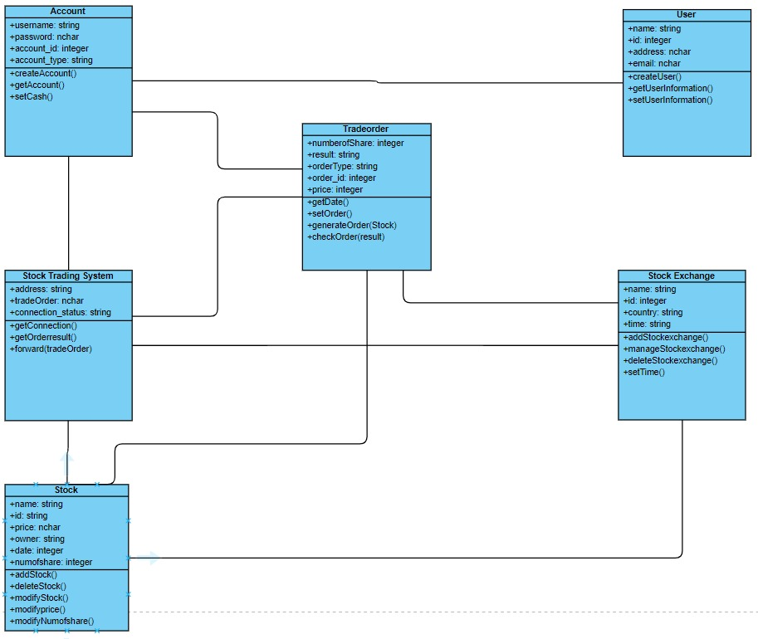

**4 Detailed Design for Module: <<Module Name>>**

[Detailed design for Module 2.]

Repeat all sub-sections given in section 3 for this module.

**5 Database Design**

[This section describes the persistent data and metadata used and generated by the module/sub-system. This will include database schemas (if the database schema is large, use a separate document for database design), registry structures, property file structures, etc.

|  |  |
| --- | --- |
| Models | Tools |
| Database Entity Relationship Diagrams | Erwin |
| Object Models | Rational Rose |

**5.1 Entity Relationship Diagrams**

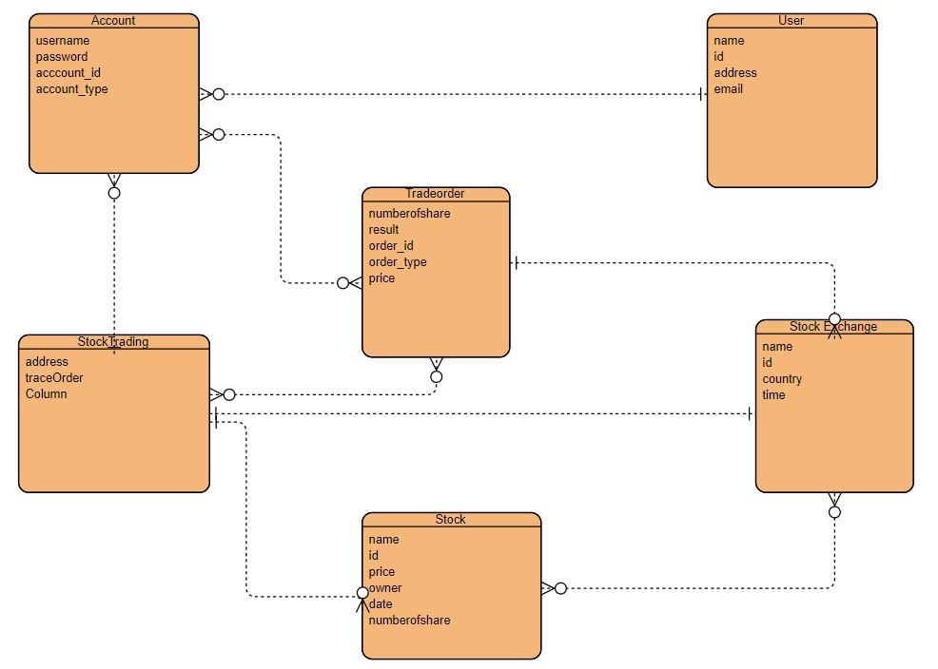

**6 Packaging/Folder Structure and System Artifacts**

[Sample structure

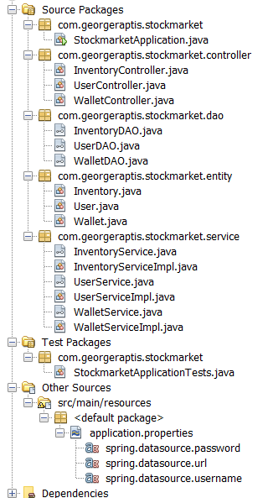

End Sample Structure]

**6.1 System Artifacts**

*[Provide information on the Registry structure, INI files, property files, configuration files, etc.]*

*Angular Dependencies.*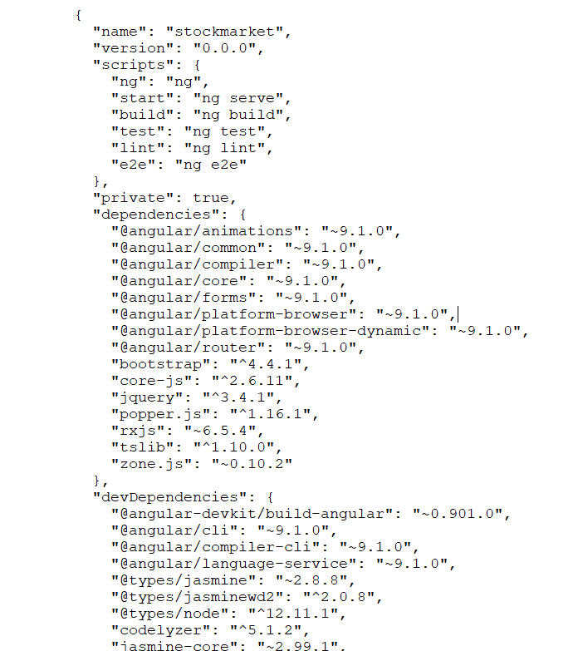

**7 Non Functional Requirements**

**Appendix**

**7.1 SNAPSHOTS:**

7.1.1 MAIN PAGE: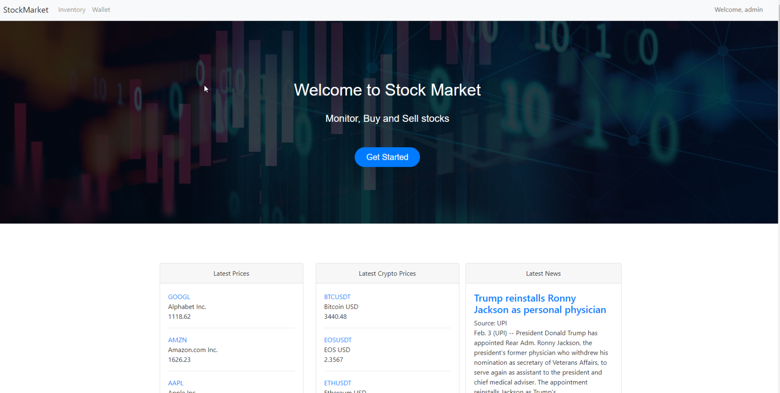7.1.2 SIGN IN PAGE: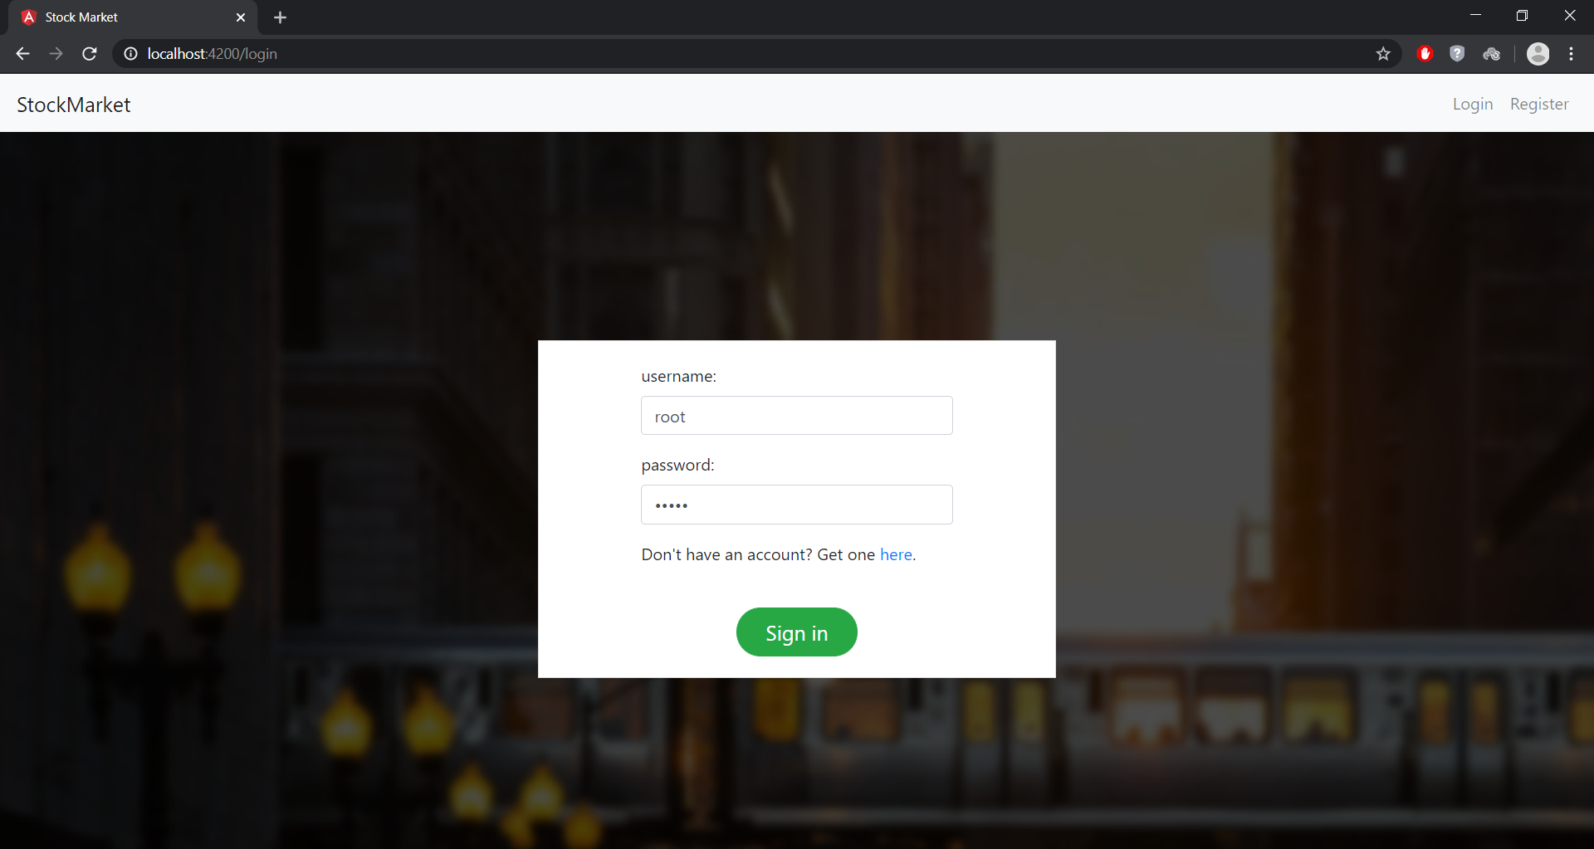

7.1.3 SIGN UP PAGE:

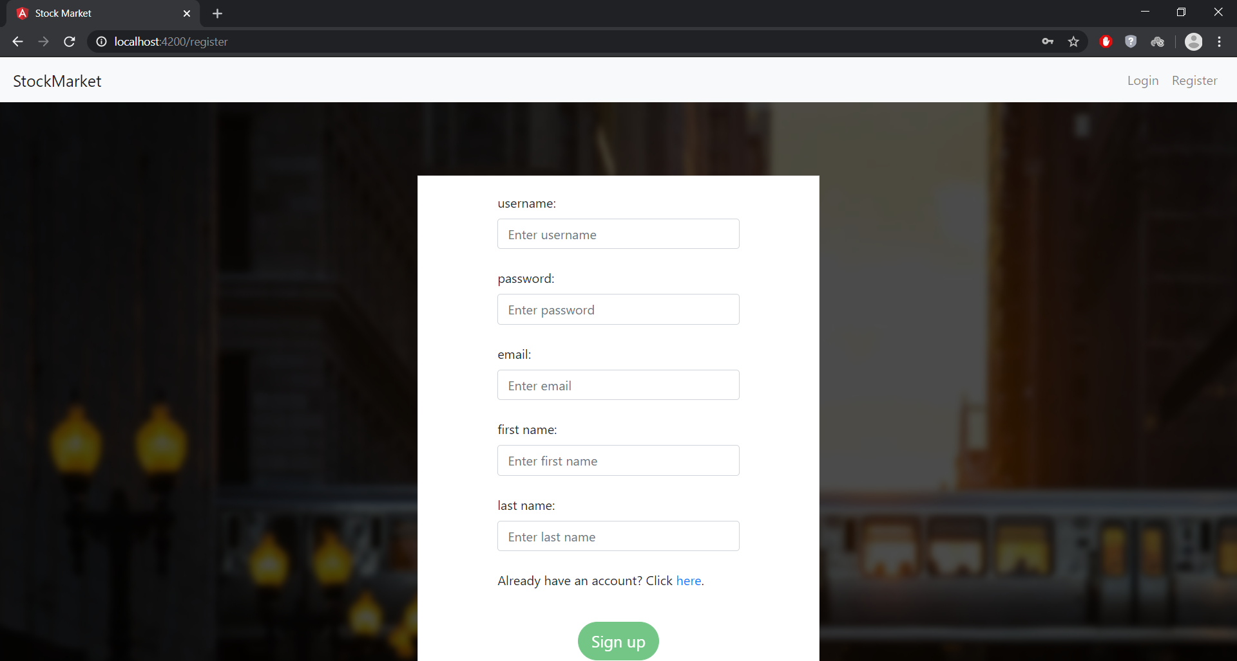

7.1.4 STOCK PAGE:

